Tab 7
ITA0601
MACHINE LEARNING

EXP 17
Implement Mobile Price Prediction using appropriate machine learning algorithm

Procedure
1. Import the Linear Regression model.
2. Create the dataset and target values.
3. Train the model using the training data.
4. Predict the mobile price for a new input.
5. Display the predicted result.

Dataset 1: Mobile Specifications vs. Price

RAM (GB) | Storage (GB) | Camera (MP) | Price (₹)
4 | 64 | 12 | 12000
4 | 128 | 16 | 15000
6 | 128 | 48 | 18000
6 | 256 | 50 | 22000
8 | 128 | 64 | 25000
8 | 256 | 64 | 30000
12 | 256 | 108 | 38000
12 | 512 | 108 | 45000
16 | 512 | 200 | 60000
16 | 1024 | 200 | 75000

Target Variable
Mobile Price (₹)

New Sample for Prediction
RAM (GB) | Storage (GB) | Camera (MP)
8 | 256 | 108

PROGRAM

import numpy as np

X=np.array([[4,64,12],[4,128,16],[6,128,48],[6,256,50],[8,128,64],
[8,256,64],[12,256,108],[12,512,108],[16,512,200],[16,1024,200]],float)
y=np.array([12000,15000,18000,22000,25000,30000,38000,45000,60000,75000],float)

X1=np.c_[np.ones(len(X)),X]
b=np.linalg.pinv(X1.T@X1)@X1.T@y

sample=np.array([1,8,256,108])
print("Predicted Mobile Price:",round(sample@b,2))

OUTPUT

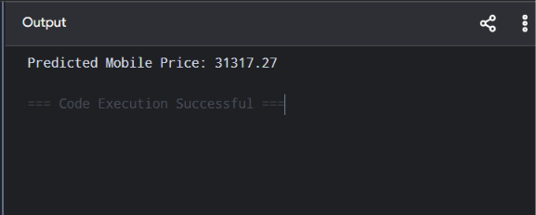

Dataset 2: Processor Performance vs. Mobile Price

Processor Speed (GHz) | RAM (GB) | Battery (mAh) | Price (₹)
1.8 | 4 | 4000 | 10000
2.0 | 4 | 4500 | 12000
2.2 | 6 | 5000 | 17000
2.4 | 6 | 5000 | 21000
2.6 | 8 | 5500 | 26000
2.8 | 8 | 6000 | 32000
3.0 | 12 | 6000 | 40000
3.2 | 12 | 6500 | 50000
3.4 | 16 | 7000 | 62000
3.6 | 16 | 7000 | 76000

Target Variable
Mobile Price (₹)

New Sample for Prediction
Processor Speed | RAM | Battery
2.9 | 8 | 6000

PROGRAM

import numpy as np

X=np.array([[1.8,4,4000],[2,4,4500],[2.2,6,5000],[2.4,6,5000],
[2.6,8,5500],[2.8,8,6000],[3,12,6000],[3.2,12,6500],
[3.4,16,7000],[3.6,16,7000]],float)
y=np.array([10000,12000,17000,21000,26000,32000,40000,50000,62000,76000],float)

X1=np.c_[np.ones(len(X)),X]
b=np.linalg.pinv(X1.T@X1)@X1.T@y

sample=np.array([1,2.9,8,6000])
print("Predicted Mobile Price:",round(sample@b,2))

OUTPUT
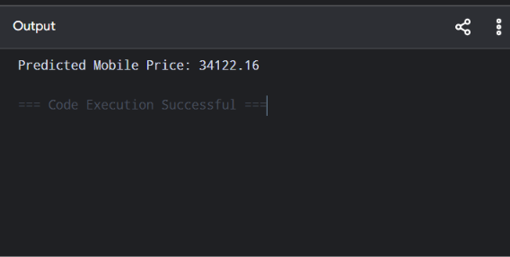

Dataset 3: Display Features vs. Mobile Price

Screen Size (inches) | Refresh Rate (Hz) | Battery (mAh) | Price (₹)
6.1 | 60 | 4000 | 12000
6.2 | 90 | 4500 | 15000
6.4 | 90 | 5000 | 18000
6.5 | 120 | 5000 | 23000
6.6 | 120 | 5500 | 28000
6.7 | 120 | 6000 | 34000
6.8 | 144 | 6000 | 42000
6.9 | 144 | 6500 | 52000
7.0 | 165 | 7000 | 65000
7.1 | 165 | 7000 | 78000

Target Variable
Mobile Price (₹)

New Sample for Prediction
Screen Size | Refresh Rate | Battery
6.7 | 144 | 6000

PROGRAM

import numpy as np

X=np.array([[6.1,60,4000],[6.2,90,4500],[6.4,90,5000],[6.5,120,5000],
[6.6,120,5500],[6.7,120,6000],[6.8,144,6000],[6.9,144,6500],
[7.0,165,7000],[7.1,165,7000]],float)
y=np.array([12000,15000,18000,23000,28000,34000,42000,52000,65000,78000],float)

X1=np.c_[np.ones(len(X)),X]
b=np.linalg.pinv(X1.T@X1)@X1.T@y

sample=np.array([1,6.7,144,6000])
print("Predicted Mobile Price:",round(sample@b,2))

OUTPUT

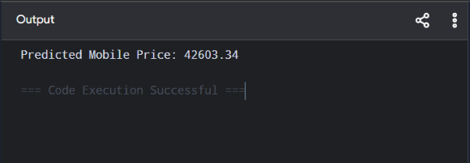

Dataset 4: Premium Smartphone Dataset

RAM (GB) | Processor Cores | Internal Storage (GB) | Price (₹)
4 | 6 | 64 | 14000
6 | 8 | 128 | 19000
8 | 8 | 128 | 26000
8 | 8 | 256 | 32000
12 | 8 | 256 | 42000
12 | 8 | 512 | 52000
16 | 8 | 512 | 65000
16 | 8 | 1024 | 82000
18 | 8 | 1024 | 95000
24 | 8 | 1024 | 120000

Target Variable
Mobile Price (₹)

New Sample for Prediction
RAM | Processor Cores | Storage
12 | 8 | 512

PROGRAM

import numpy as np

X=np.array([[4,6,64],[6,8,128],[8,8,128],[8,8,256],[12,8,256],
[12,8,512],[16,8,512],[16,8,1024],[18,8,1024],[24,8,1024]],float)
y=np.array([14000,19000,26000,32000,42000,52000,65000,82000,95000,120000],float)

X1=np.c_[np.ones(len(X)),X]
b=np.linalg.pinv(X1.T@X1)@X1.T@y

sample=np.array([1,12,8,512])
print("Predicted Mobile Price:",round(sample@b,2))

OUTPUT

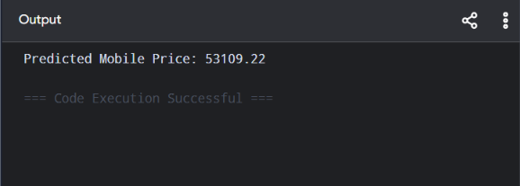

Dataset 5: Overall Mobile Performance Dataset

Antutu Score | Battery (mAh) | Camera (MP) | Price (₹)
250000 | 4000 | 48 | 15000
320000 | 4500 | 50 | 18000
420000 | 5000 | 64 | 24000
520000 | 5000 | 64 | 30000
620000 | 5500 | 108 | 38000
720000 | 6000 | 108 | 46000
820000 | 6000 | 200 | 58000
920000 | 6500 | 200 | 70000
1020000 | 7000 | 200 | 85000
1120000 | 7000 | 200 | 100000

Target Variable
Mobile Price (₹)

New Sample for Prediction
Antutu Score | Battery | Camera
750000 | 6000 | 108

PROGRAM

import numpy as np

X=np.array([[250000,4000,48],[320000,4500,50],[420000,5000,64],
[520000,5000,64],[620000,5500,108],[720000,6000,108],
[820000,6000,200],[920000,6500,200],[1020000,7000,200],
[1120000,7000,200]],float)
y=np.array([15000,18000,24000,30000,38000,46000,58000,70000,85000,100000],float)

X1=np.c_[np.ones(len(X)),X]
b=np.linalg.pinv(X1.T@X1)@X1.T@y

sample=np.array([1,750000,6000,108])
print("Predicted Mobile Price:",round(sample@b,2))

OUTPUT

